Ramdeobaba University, Nagpur
Department of Computer Science and Engineering
Session: 2025-26

Subject: Design and Analysis of Algorithms (DAA) Lab Project
III Semester
LAB PROJECT REPORT

Group Members with Roll number and Section:
A1-B2-30 Archit Deshpande
A1-B2-26 Ayush Dutta
A1-B4-66 Sahil Deshmukh

GITHUB link of Project repo and deployment link (if website): DAA-LAB-/Lab_Project_DocMatchPro at main · DuttaAyush/DAA-LAB-

TITLE:
DocMatchPro: Intelligent Document Comparison and Plagiarism Detection Tool

Objectives:
- To develop a robust document comparison tool that detects plagiarism and measures textual similarity.
- To analyse both semantic and structural similarities between two documents.
- To implement multiple algorithms for comprehensive comparison: TF-IDF + Cosine Similarity, Longest Common Subsequence (LCS), and Edit Distance.
- To provide a user-friendly interface for academic, professional, and legal use cases.
- To visualize similarity metrics and highlight matched or paraphrased segments.

Introduction:
DocMatchPro is a smart document comparison tool designed to detect plagiarism and measure how similar two texts are — both in meaning and structure. It combines semantic analysis with structural matching to identify copied, paraphrased, or reordered content. The tool is especially useful for academic integrity checks, resume-job matching, and legal document analysis. By integrating multiple algorithms, DocMatchPro ensures high accuracy and flexibility across different use cases

Algorithms/Technique used:
1. TF-IDF + Cosine Similarity
- Purpose: Measures semantic similarity between documents.
- Algorithm:
  - Compute Term Frequency (TF) and Inverse Document Frequency (IDF) for each word.
  - Generate TF-IDF vectors for both documents.
- Explanation: Captures how similar the documents are based on word importance and distribution.
- Diagram:
- [Doc A] → TF-IDF Vector A
- [Doc B] → TF-IDF Vector B
- → Cosine Similarity Score

2. Longest Common Subsequence (LCS)
- Purpose: Detects reordered or copied blocks of text.
- Algorithm:
  - Use dynamic programming to find the longest sequence of words common to both documents in order.
- Explanation: Identifies large blocks of matching text even if the order is slightly changed.
- Diagram:
- [Doc A] → Word Sequence
- [Doc B] → Word Sequence
- → LCS Matrix → Highlighted Matches

3. Edit Distance (Levenshtein Distance)
- Purpose: Captures paraphrased or slightly modified sentences.
- Algorithm:
  - Calculate the minimum number of insertions, deletions, and substitutions to convert one string into another.
- Explanation: Useful for detecting paraphrasing and minor edits.
- Diagram:
- [Sentence A] ↔ [Sentence B]
- → Edit Distance Matrix → Similarity Score

Time Complexity and its explanation:

Algorithm | Time Complexity
TF-IDF + Cosine Similarity | O(n*m)
Longest Common Subsequence | O(n*m)
Edit Distance | O(n*m)

Where:
- n = length of Document/String A
- m = length of Document/String B

Results:
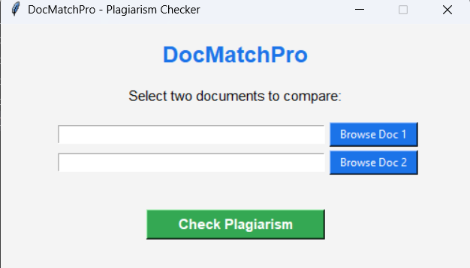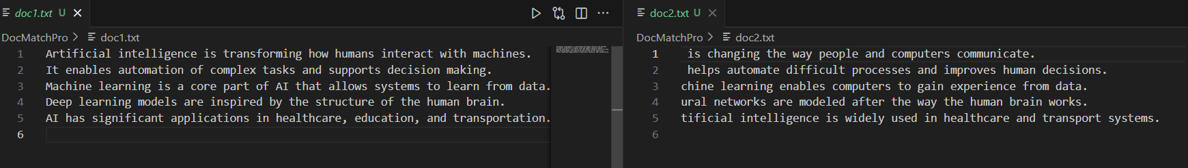
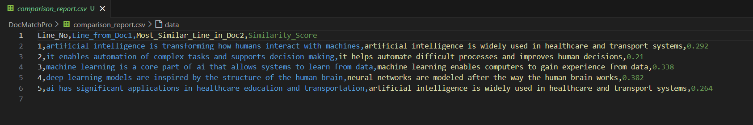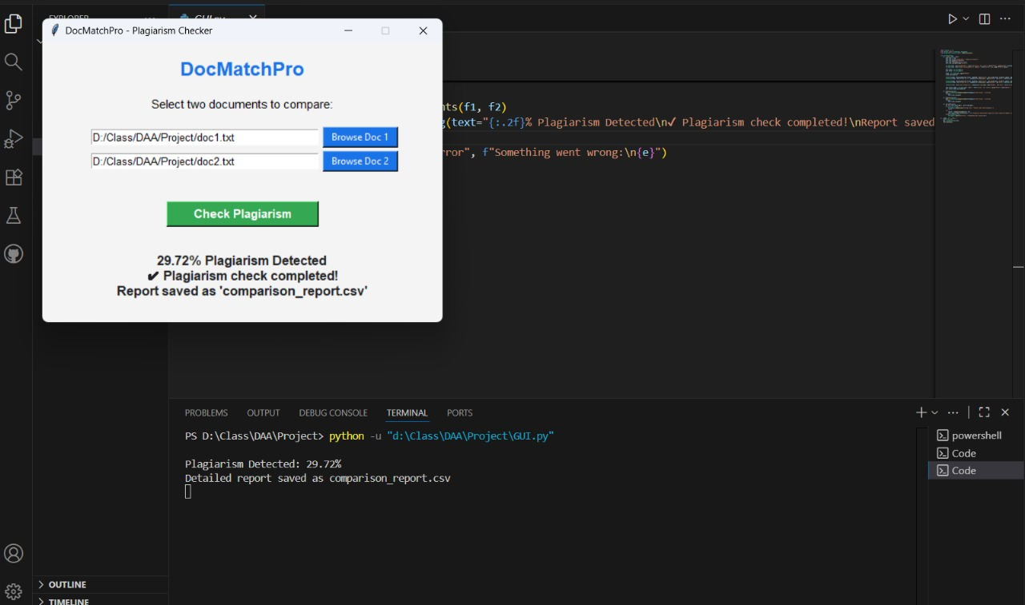

Conclusion and future scope:
DocMatchPro successfully integrates semantic and structural comparison techniques to detect plagiarism and measure document similarity. It provides a multi-layered analysis that goes beyond simple word matching, making it suitable for academic, professional, and legal applications.

Future Scope:
- Integrate NLP models like BERT for deeper semantic understanding.
- Add support for multilingual document comparison.
- Include visualization tools like heatmaps and similarity graphs.
- Expand to compare more than two documents simultaneously.

